Assignment 2

Name: Mohanish Khambadkar

Roll No.: 207

Division: C

Batch: C3

Problem Statement:

Write a program in C++ to implement the following operations on Threaded Binary Tree : create,recursive inorder traversal, recursive preorder traversal, recursive postorder traversal, non recursive inorder traversal.

Code

#include<iostream>

using namespace std;

#define maxval 9999

class node{

public:

int k;

node *left,*right;

bool rith,leth;

};

class TBT{

public:

node *root;

TBT(){

root= new node();

root->right= root->left= root;

root->leth = true;

root->k = maxval;

}

void insert(int key){

node *p=root;

for(;;){

if(p->k<key){

if(p->rith)

break;

p=p->right;

}

else if(p->k>key){

if(p->leth)

break;

p=p->left;

}

else{

return;

}

}

node *temp=new node();

temp->k=key;

temp->rith=temp->leth=true;

if(p->k<key){

temp->right=p->right;

temp->left=p;

p->right=temp;

p->rith=false;

}

else{

temp->right=p;

temp->left=p->left;

p->left=temp;

p->leth=false;

}

}

void create_TBT(){

int n,ch=1;

do{

cout<<"\nEnter value:";

cin>>n;

insert(n);

cout<<"\nWant to continue(1/0): ";

cin>>ch;

}while(ch!=0);

}

void inorder_rec(node *temp){

if(temp!=NULL){

if(temp->leth==false)

inorder_rec(temp->left);

cout<<"\t"<<temp->k;

if(temp->rith==false)

inorder_rec(temp->right);

}

}

void postorder_rec(node *temp){

if (temp!=NULL){

if(temp->leth==false)

postorder_rec(temp->left);

if(temp->rith==false)

postorder_rec(temp->right);

cout<<"\t"<<temp->k;

}

}

void preorder_rec(node *temp){

if (temp!=NULL){

cout<<"\t"<<temp->k;

if(temp->leth==false)

preorder_rec(temp->left);

if(temp->rith==false)

preorder_rec(temp->right);

}

}

node* inorder_successor(node *t1){

if(t1->rith== 1)

t1 = t1->right;

else{

t1 = t1->right;

while(t1->leth == 0)

t1 = t1->left;

}

return t1;

}

void inorder_traversal() {

node *t1 = root->left;

while(t1->leth == 0)

t1 = t1->left;

while(t1!=root){

cout<<"\t"<<t1->k;

t1 = inorder_successor(t1);

}

}

};

int main(){

TBT t;

int ch;

do{

cout<<"\nChoose the choices from the following opitions: ";

cout<<"\n1. Create TBT\n2. Inorder Recursive Traversal\n3. Postorder Recursive Traversal\n4. Preorder Recursive Traversal\n5. Inorder Non recursive Traversal\n6. Exit.\nEnter choice: ";

cin>>ch;

switch(ch){

case 1:{

t.create_TBT();

break;

}

case 2:{

cout<<"\nInorder Recursive Traversal"<<endl;

t.inorder_rec(t.root->left);

break;

}

case 3:{

cout<<"\nPostorder Recursive Traversal"<<endl;

t.postorder_rec(t.root->left);

break;

}

case 4:{

cout<<"\nPreorder Recursive Traversal"<<endl;

t.preorder_rec(t.root->left);

break;

}

case 5:{

cout<<"\nInorder Non Recursive Traversal"<<endl;

t.inorder_traversal();

break;

}

}

}while(ch!=6);

return 0;

}

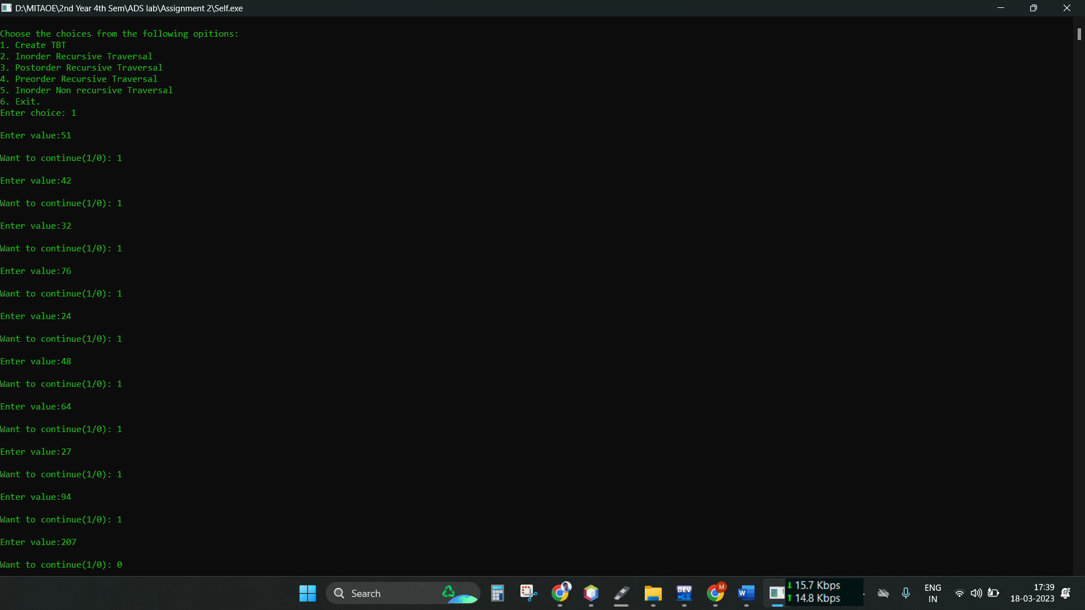OUTPUT:

